Experiment 13
Implement the Car Price Prediction Model using Python
Aim
To implement a Car Price Prediction Model using Python to predict the price of a car based on given features using Linear Regression.
Program
# Car Price Prediction using Linear Regression
import pandas as pd
from sklearn.linear_model import LinearRegression
from sklearn.metrics import mean_squared_error

# Dataset
data = {
'Year': [2015, 2016, 2017, 2018, 2019],
'Engine_Size': [1200, 1500, 1300, 1800, 2000],
'Price': [500000, 600000, 650000, 700000, 800000]
}
df = pd.DataFrame(data)

# Features and target
X = df[['Year','Engine_Size']]
y = df['Price']

# Model
model = LinearRegression()
model.fit(X, y)
# Prediction
y_pred = model.predict(X)
print("Actual Prices:", list(y))
print("Predicted Prices:", list(y_pred))
mse = mean_squared_error(y, y_pred)
print("Mean Squared Error:", mse)
Output
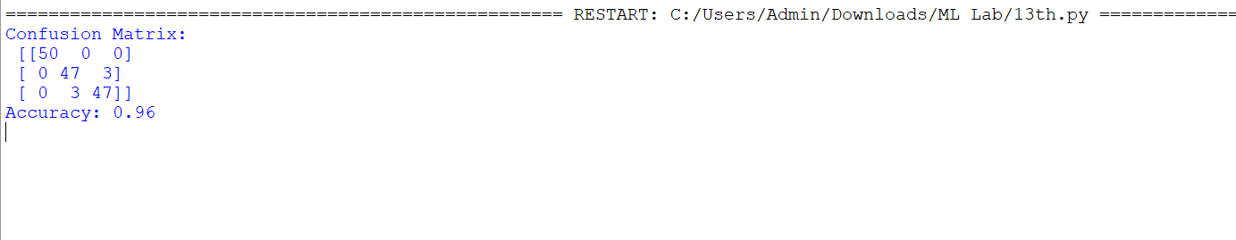

Result
The Car Price Prediction model was successfully implemented in Python using Linear Regression to predict car prices based on given features.

